**7.1.11. Sensitization of students and employees of the Institution to the constitutional obligations:values, rights, duties and responsibilities of citizens** India is a land of rich traditions and culture. Each festival has significance. All these festivals are relevant to seasonal changes. Pongal or Sankranthi is a festival of harvest. In this, the freshly harvested rice and preparation of its Pongal play a significant role.

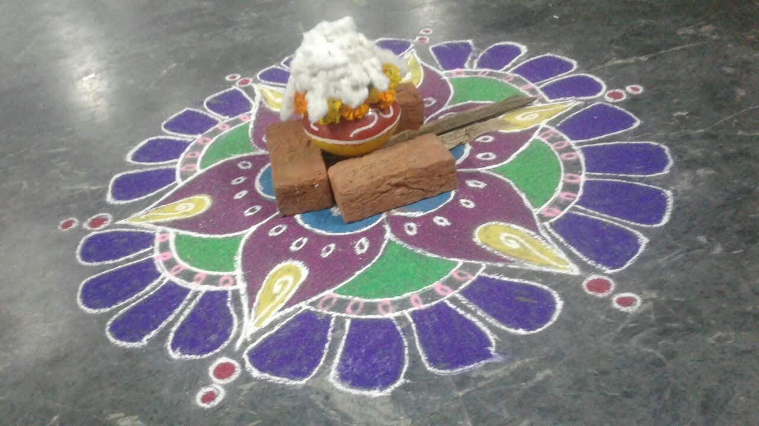

Sivaratri marks the beginning of spring and is significant for fasting.

Ugadi, Telugu new year begins with the preparation of a 'pachadi' comprising of 6tastes.

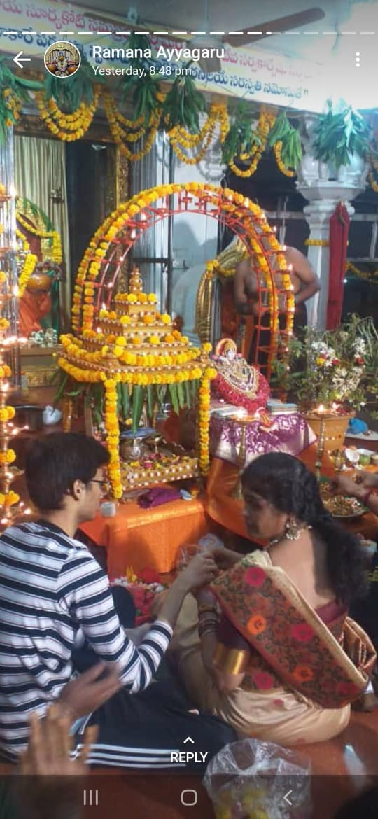

**Ramanavami** has its significance in the preparation of jaggery water with pepper and cardamom 'panakam.' 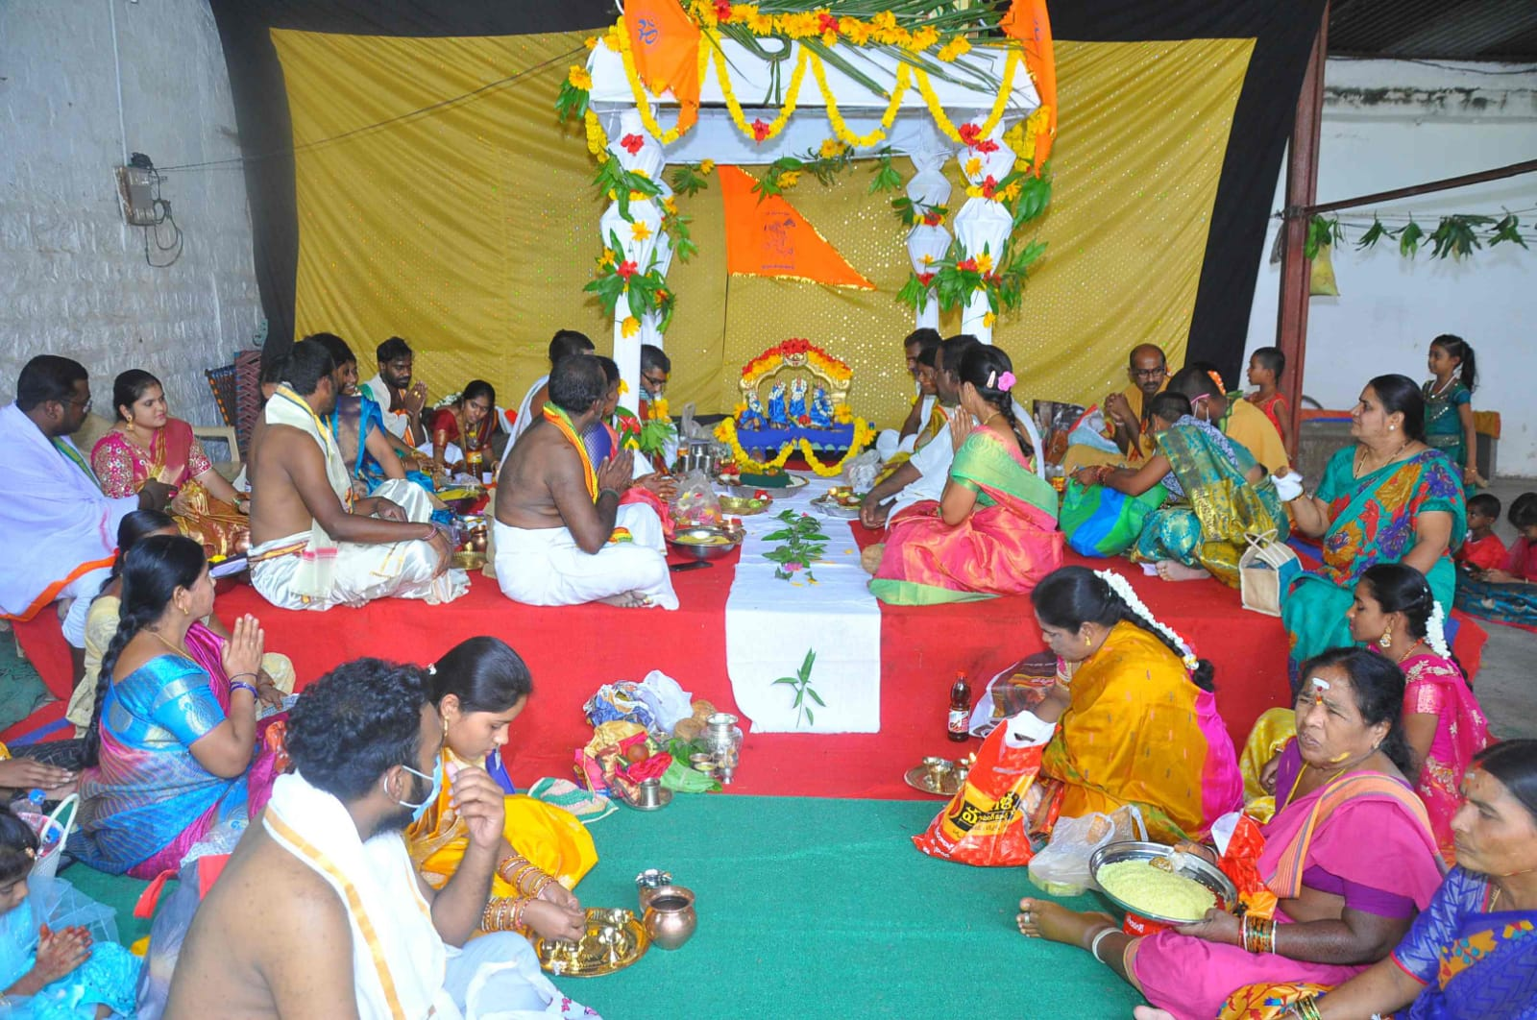

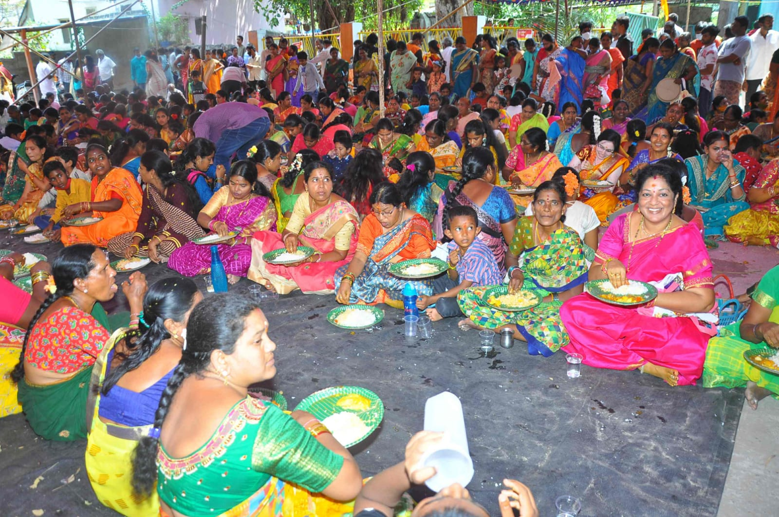

,

**National Youth Day**

* **National youth day is conducted** on January 12. Vivekananda is a source of inspiration to the Youth. Creates awareness among the Youth with relation to national development.

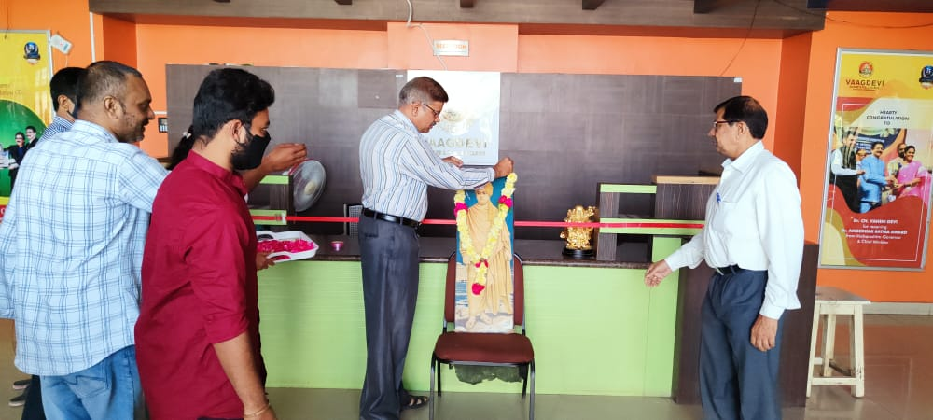

**Drivers Day**

* **National Drivers day** is being celebrated to recognize the hard work and contribution of drivers towards the growth of the logistic sector in India.

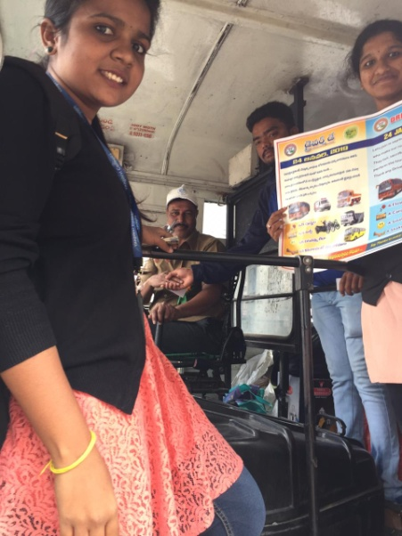

**National Science Day**

* It is celebrated on Feb 28 to commemorate CV Raman Effect

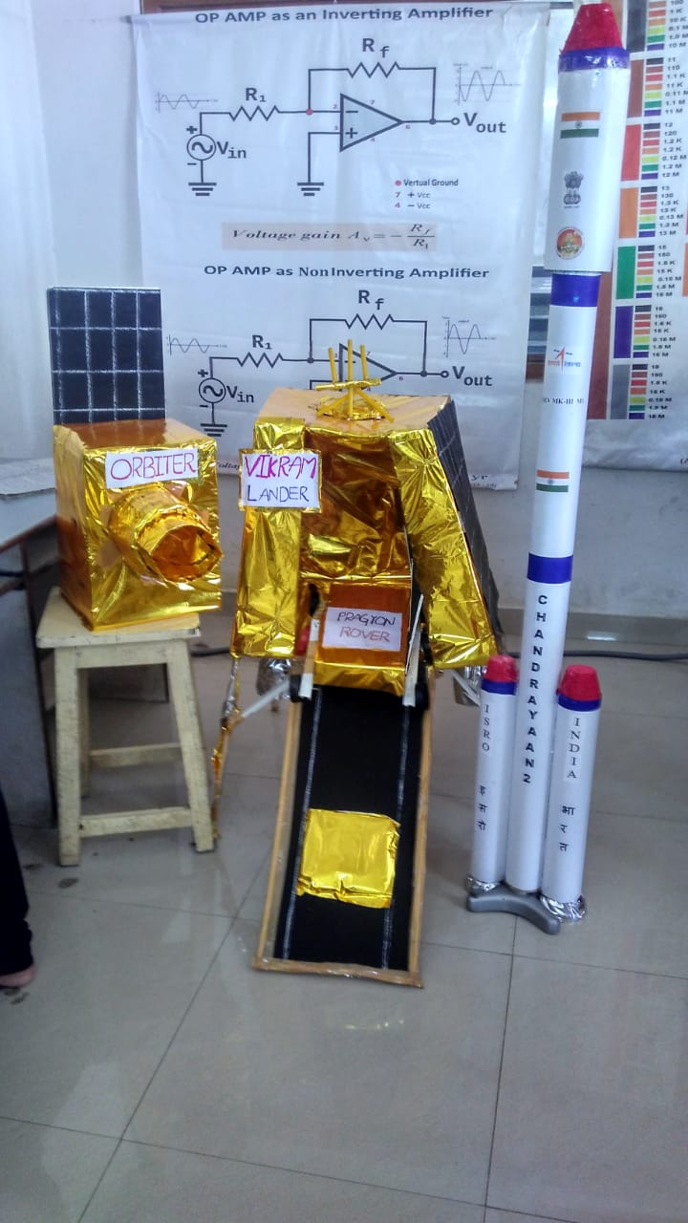

**International Women's DayInternational women’s Day on March 8** is being celebrated to help women get empowered and instill a sense of confidence and security in women

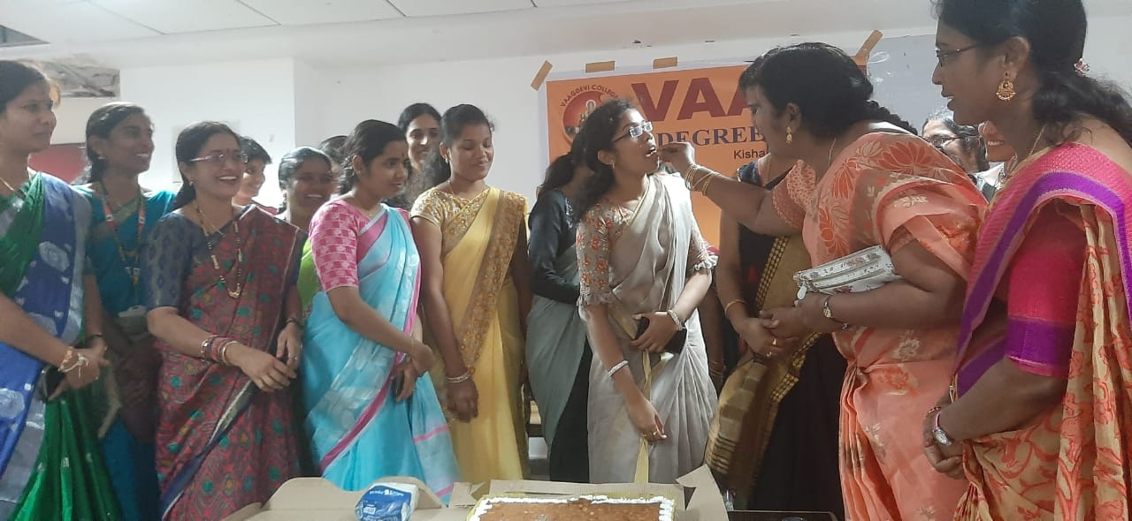

**Consumer Rights Day**

* **World Consumer Rights** .on March 15 helps in creating awareness of consumer rights in the world and helps in taking the right decision, the right choice and information, and the right to safety.

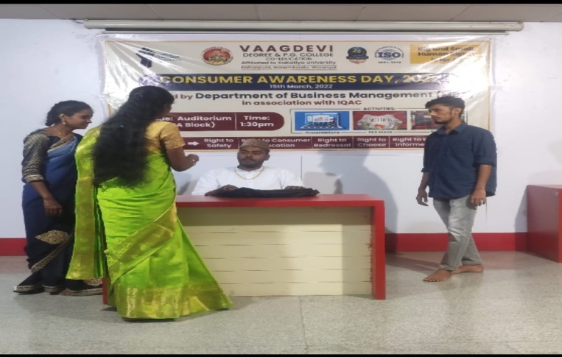

**World Water Day**

**Water day on March** 22 advocates for the sustainable management of freshwater resources.

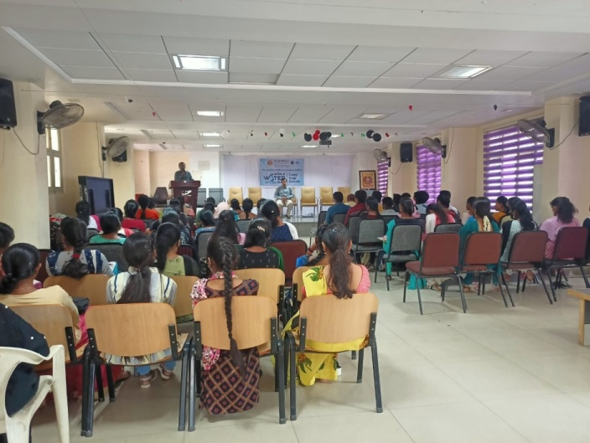

**Bhagath Singh Jayanthi**

* **Bhagath Singh Jayanthi** on March 23 is celebrated to retain his fervor of patriotism.

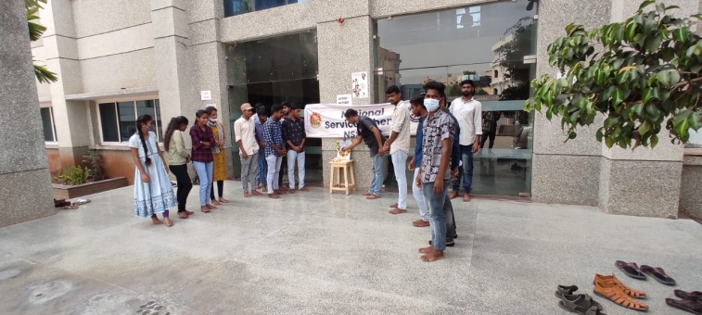

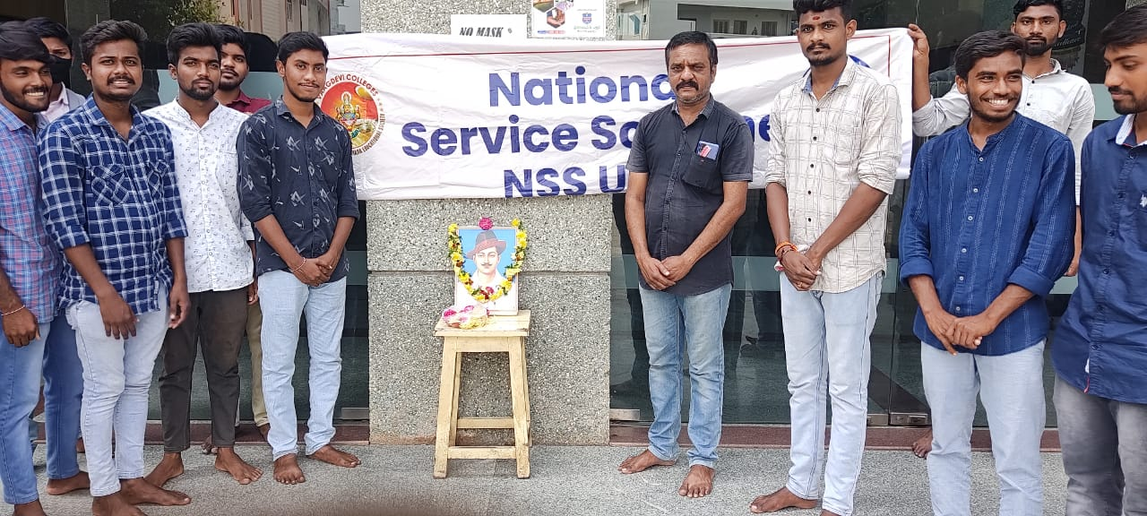

**World Tuberculosis Day**

* **World Tuberculosis Day on March** 24 is celebrated to create awareness of one of the deadliest infectious diseases affecting the world. Awareness can help in preventing as well as curing it.

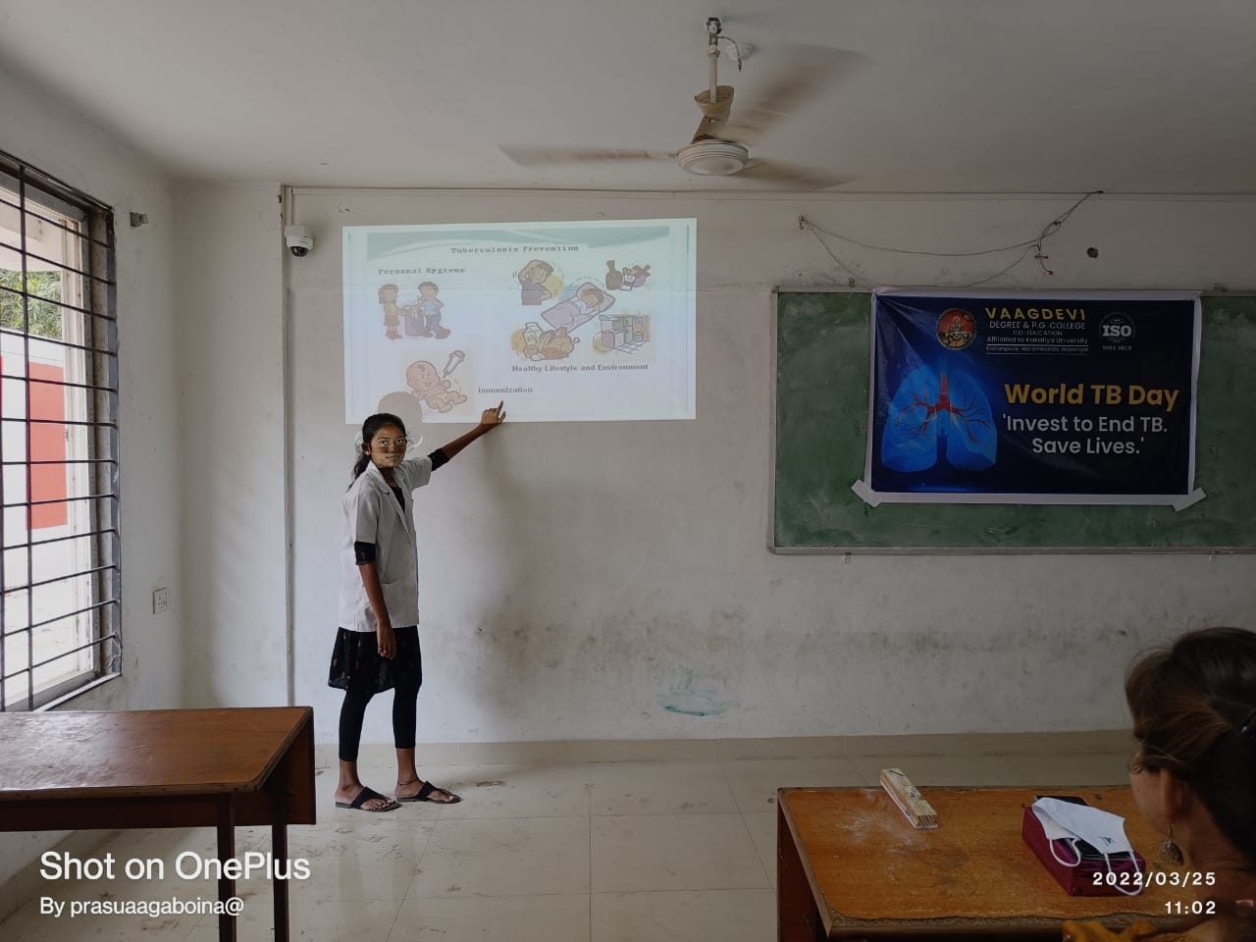

**World hemophilia dayWorld hemophilia day on April** 17 was created to raise awareness regarding bleeding disorders.

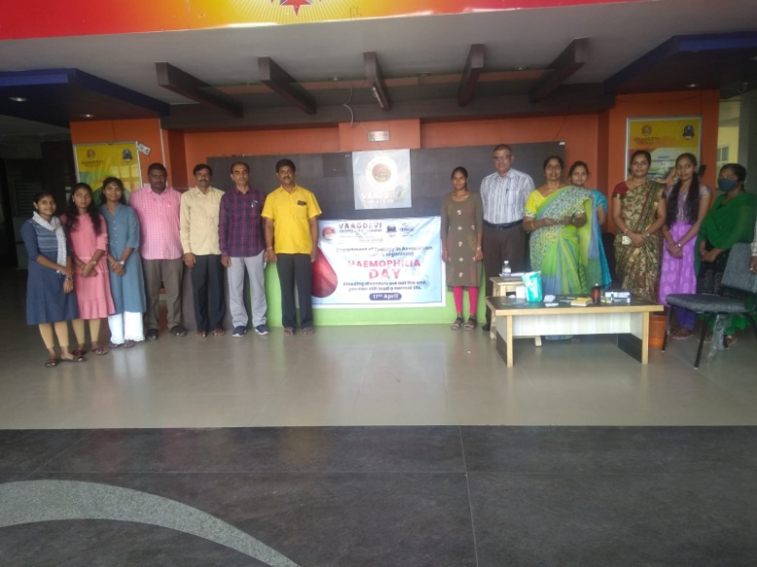

**World Heritage Day**

**World heritage day**, April 18, helps in understanding the importance of the preservation of our heritage. Warangal has been successful in ensuring the recognition of Ramappa as a UNESCO world heritage center.

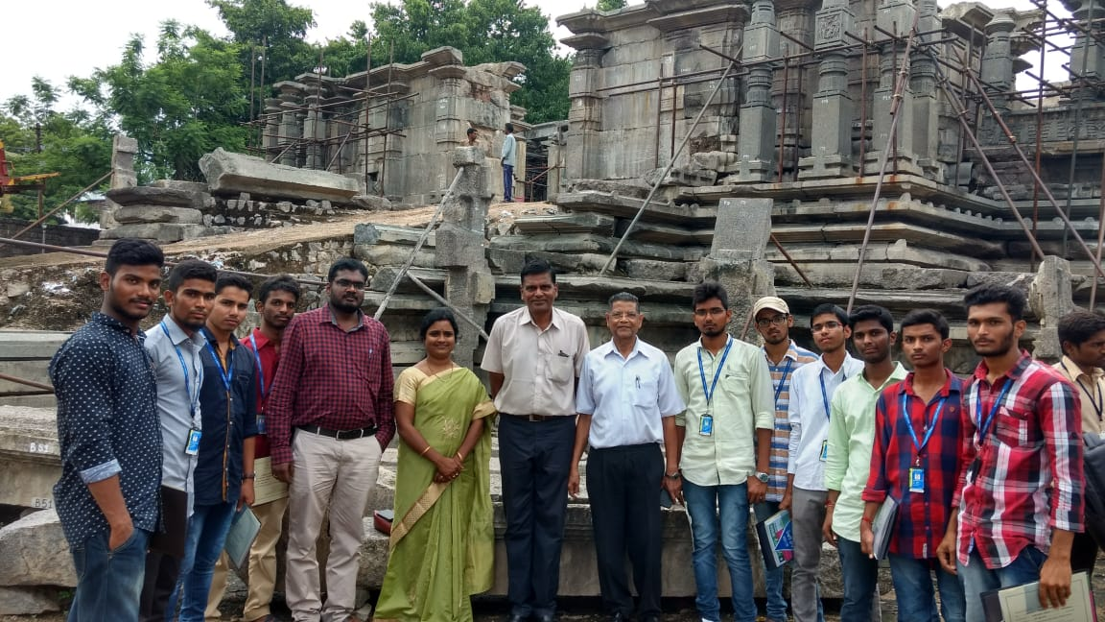

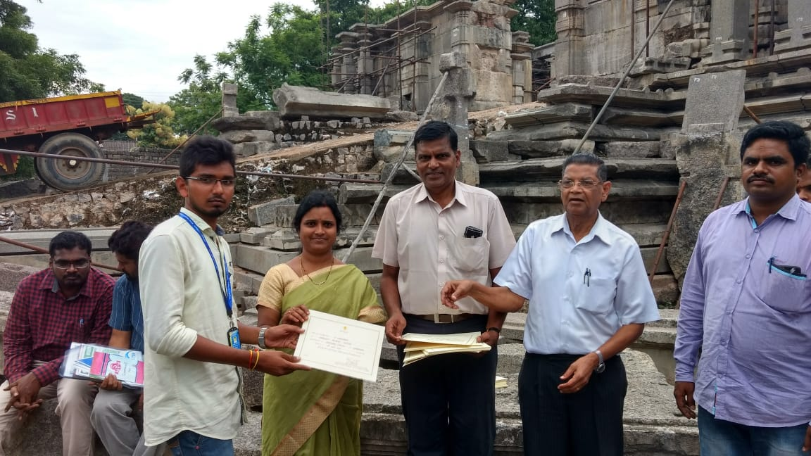

**Earth Day**

* **World Earth Day** on April 22 helps to create awareness regarding the protection of the earth and to reduce pollution.

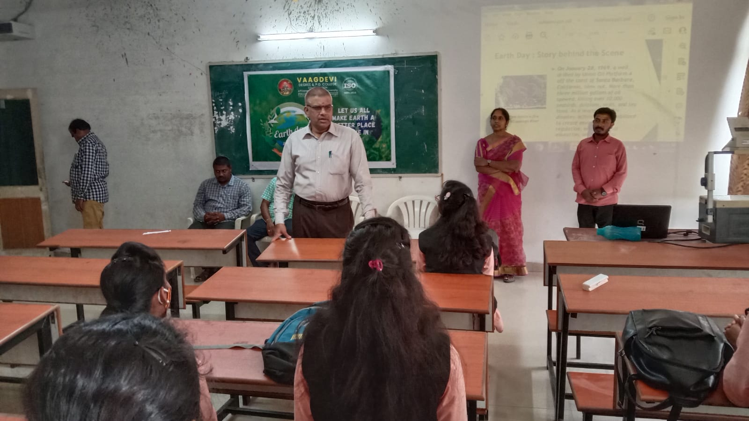

**World Malaria Day**

* **World Malaria Day** on April 25 is observed to highlight the need for continued investment and sustained political commitment to preventing and controlling malaria across the globe.

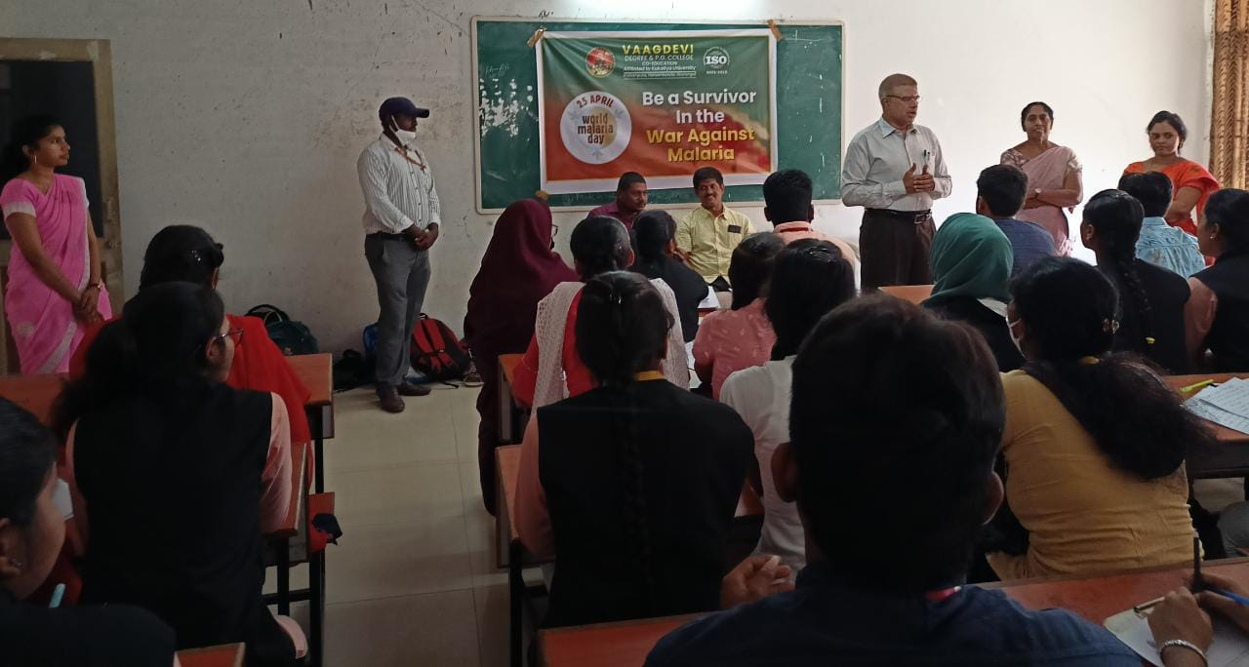

**World Intellectual Property day**

* **World Intellectual Property** Day on April 26 is important in enhancing information about the role of intellectual property rights in encouraging innovation and creativity.

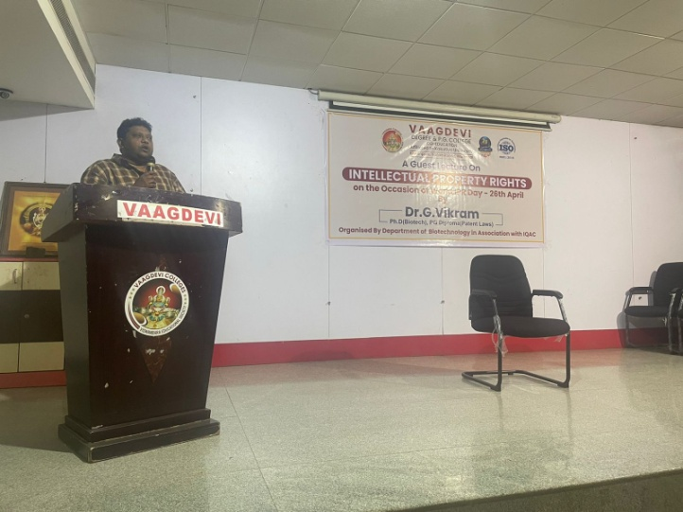

**International Dance Day**

* **International Dance Day** on April 29 is celebrated to encourage participation and create awareness among the people on different forms of dance.

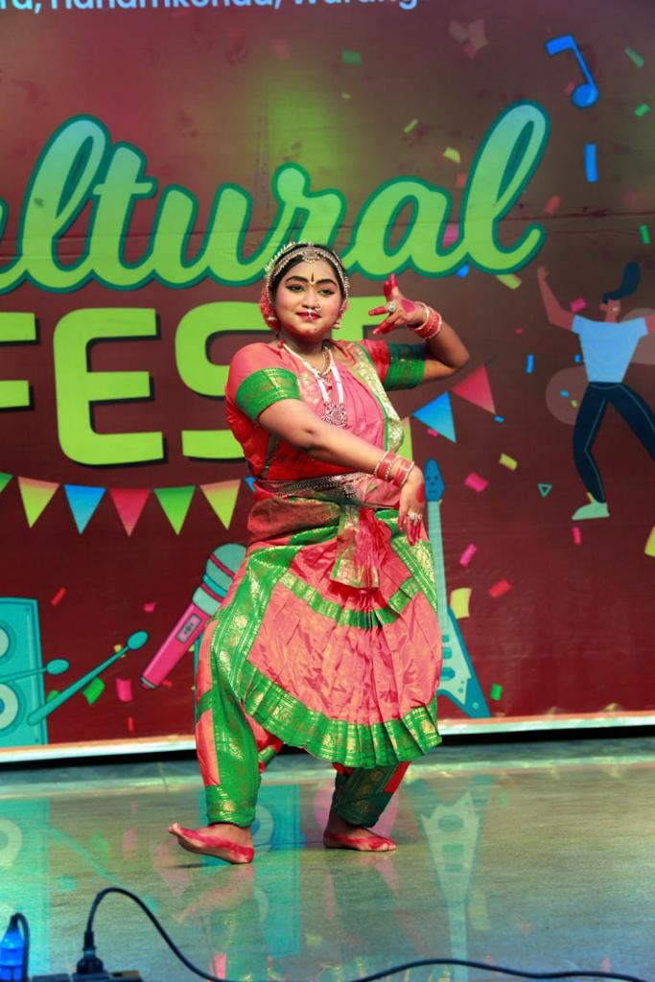

**Environment Day**

* **Environment day on** June 5 is being celebrated to create awareness and encourage action for the protection of the environment.

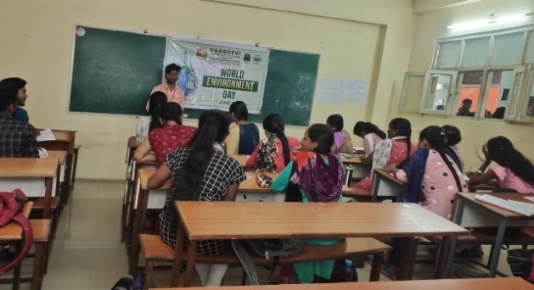

**International Yoga Day**

* **International Yoga day on** June 21 is celebrated to signify a way of uniting the "individual self" consciously with the cosmos.

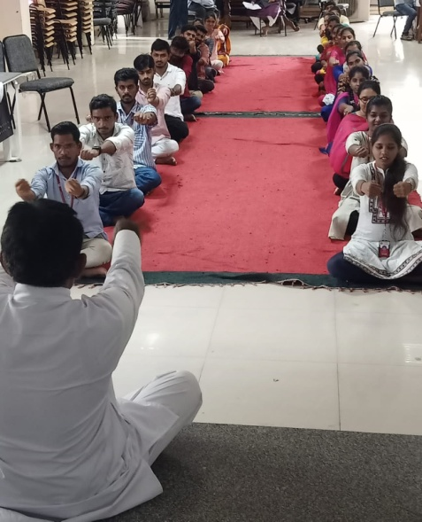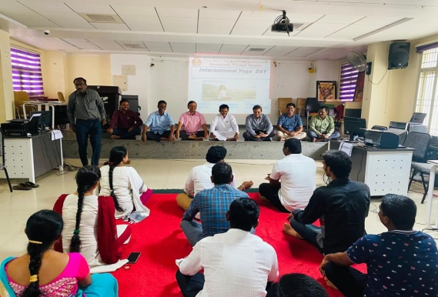

**Teachers Day**

* **Teacher's day on September** 5 is celebrated to commemorate the significant role being played by teachers in molding the students into future citizens of the nation.

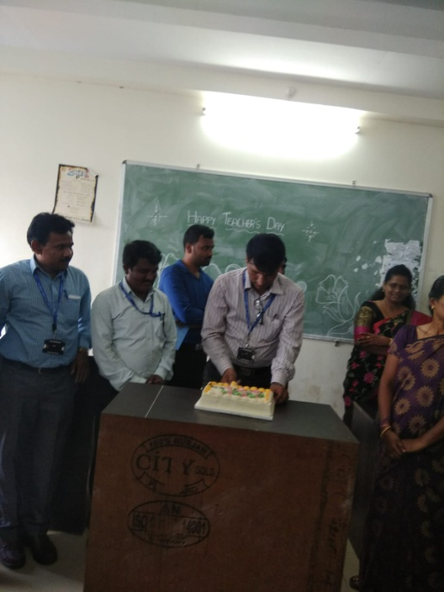

**World Suicide Prevention Day**

* **World suicide prevention day** on September 10 has been initiated to prevent the suicide tendency being developed in the younger generations and offer to counsel to the younger generation.

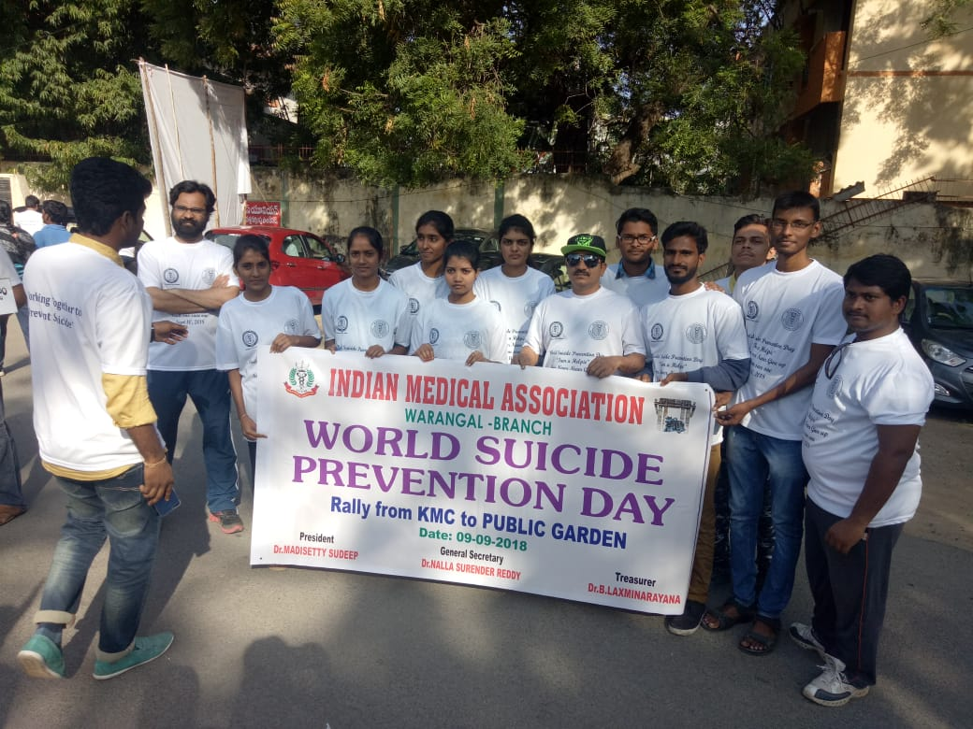

**Gandhi Jayanthi**

* **Gandhi Jayanthi** on October 2 is celebrated in memory of the Father of the Nation to pay tribute to the man who strived to ensure that we could live in a free India.

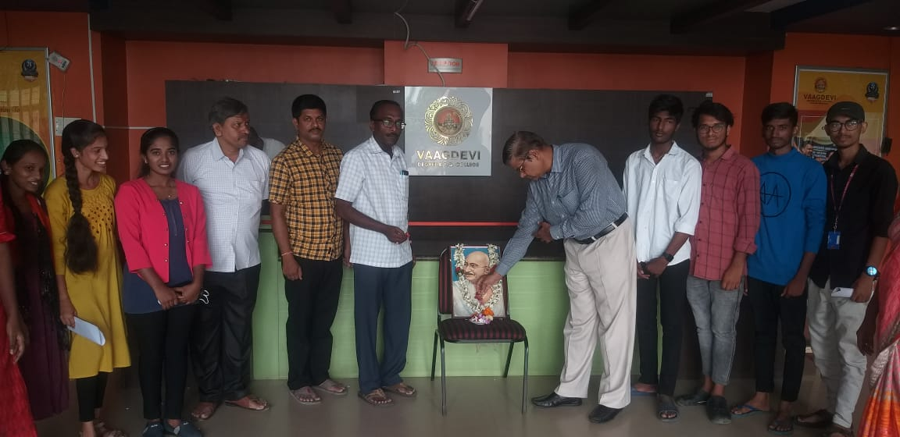

**National Mathematics Day**

* **National mathematics day** is celebrated on December 22 to commemorate Srinivas Ramanujam, who showed the signs of an unfolding genius and his contributions regarding fractions, infinite series, number theory, mathematical analysis, etc.

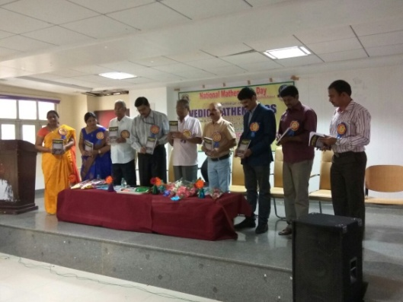

**Aids Day**

* **AIDS Day is on December 1** to create awareness about the disease. To express empathy with patients and to take up preventive measures.

